

**Sehrish Mubarik**

**BSAIM-F23-001(4A)**

**Assignment no 04**

**Submitted to:**

**Sir Rasikh ali**

**Lab tasks**

**Question no 01**

**API backend + frontend**

**Html:**

<!DOCTYPE html>

<html lang="en">

<head>

    <meta charset="UTF-8">

    <meta name="viewport" content="width=device-width, initial-scale=1.0">

    <title>Recipe App</title>

    <link rel="stylesheet" href="{{ url_for('static', filename='style.css') }}">

</head>

<body>

    <div class="container">

        <h1>Random Recipe</h1>

        {% if apod %}

            <h2>{{ apod["recipes"][0]["title"] }}</h2>

            <img src="{{ apod['recipes'][0]['image'] }}" alt="Recipe Image">

            <h3>Ingredients:</h3>

            <ul>

                {% for ingredient in apod["recipes"][0]["extendedIngredients"] %}

                    <li>{{ ingredient["original"] }}</li>

                {% endfor %}

            </ul>

            <h3>Instructions:</h3>

            <p>{{ apod["recipes"][0]["instructions"] }}</p>

        {% else %}

            <p>No Recipe Found</p>

        {% endif %}

        <button onclick="getNewRecipe()">Get Another Recipe</button>

    </div>

    <script src="{{ url_for('static', filename='script.js') }}"></script>

</body>

</html>

**Css**

body {

    font-family: Arial, sans-serif;

    text-align: center;

    padding: 20px;

    background-color: #f8f8f8;

}

.container {

    max-width: 600px;

    margin: auto;

    background: white;

    padding: 20px;

    border-radius: 10px;

    box-shadow: 0 4px 8px rgba(0, 0, 0, 0.1);

}

img {

    width: 100%;

    border-radius: 10px;

}

button {

    margin-top: 15px;

    padding: 10px 20px;

    font-size: 16px;

    background: #ff5722;

    color: white;

    border: none;

    border-radius: 5px;

    cursor: pointer;

}

button:hover {

    background: #e64a19;

}

**Java**

function getNewRecipe() {

    location.reload(); // Reloads the page to fetch a new recipe

}

**Output**

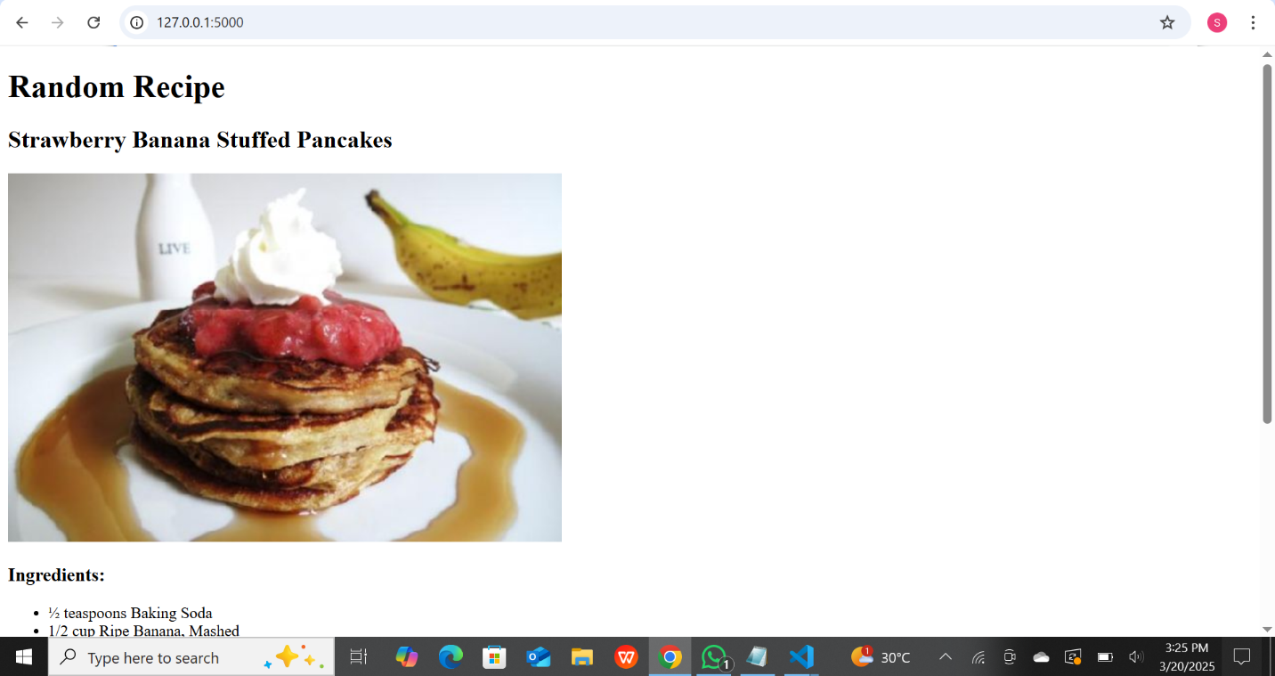

**Output2**

